Wesley Muehlhausen  
HW2 Writeup  
CPSC 224

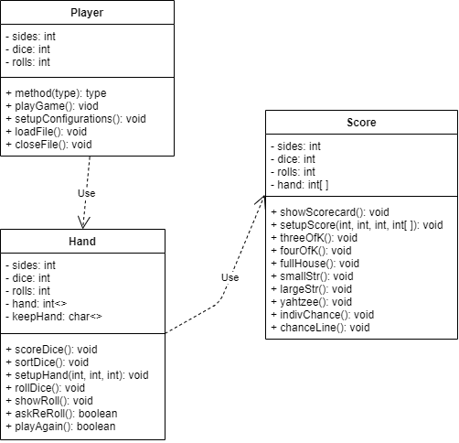In this project, we created the Yahtzee game. This game works for a single person and shows the score of each hand but does not keep the scores of more than one time rolling through i.e. a scorecard. The basic run through of this program is that it starts by stating what the game configuration is, it then asks if you want to change it. Then it runs though the game and scores the game. There are a few changes from last homework including having the ability to chose n sides, dice, and rolls in the game. The scoring also adjusted to this change. The design I chose for this was pretty simple. In the main file I call create an object that runs the Player class, which runs the file I/O as well as calls the Hand class to run. Inside the hand class, all of the mechanics of the game happen like rolling the hand of dice and rerolling etc. called inside of that function is the score class which does all the scoring.

This project went a lot smoother than homework 1. I did have heaps of trouble when making my individual chance slots work in the Score class. I kept on getting array out of index errors when the for loop made sense in my head. I finally had to get out a piece of paper and write down everything step by step and realized what I was doing. Most of my scoring functions worked from homework 1 so there was little change there and the file importing and outputting was no problem after Gina’s video.

If I had more time, I would make my program work with an n-of a kind method so I wouldn’t just have three and four of a kind on the scoreboard. Overall I am pretty happy with what I have come up with.